April 2, 2024

Katherine Brown  
Tribal Trust and Assistance Branch  
Regional Administrator's Division (TTAB-122)  
1200 6th Avenue, Suite 155  
Seattle, WA 98101

Email: [brown.katherine@epa.gov](mailto:brown.katherine@epa.gov)

Dear Ms. Brown,

Kenai Watershed Forum coordinates the efforts of a multi-agency water quality monitoring program focused on the Kenai River in south central Alaska. We are providing this technical memo to inform the EPA Region 10 office of several minor revisions to the project’s current Quality Assurance Project Plan (QAPP). The changes include the following items:

* Updating personnel name changes on the distribution list and technical advisory committee
* Including use of new models of hand-held water probes to collect intrinsic water quality parameter observations:
  + YSI ProQuatro (pH, temperature, conductivity, dissolved oxygen)
  + Hach 2100P (turbidity)
* Describing where, when, and how additional observations of the five parameters listed above may be collected, using the new hand-held probes. (“Additional,” to mean occurring on dates outside of solely the two standard spring & summer dates currently described in the QAPP)

No reductions of data quality objectives, additions of new parameters, or changes to sample locations are included in this technical memo. We intend to initiate these changes by May 8, 2024.

We have documented the proposed changes within this technical memo and will publish it as an addendum to the full QAPP document posted on [www.kenaiwatershed.org](http://www.kenaiwatershed.org). When a future opportunity occurs to conduct a formal revision of the QAPP, we will incorporate these changes in to the proposed document edits.

Thank you for your time and assistance. Sincerely,

  
Benjamin Meyer  
Kenai Watershed Forum, Environmental Scientist  
[ben@kenaiwatershed.org](mailto:ben@kenaiwatershed.org)  
(907) 232-0280

**April 2024**

**Revisions to “Kenai River Water Quality Monitoring Quality Assurance Project Plan (QAPP), Multi-Agency Baseline, v3,” available at the web address in the footnote[1].**

1. ***Updating personnel names on the distribution list and technical advisory committee (arrow indicates change)***

* Page 7, “A4. Distribution List”
  + Mitch Michaud 🡪 Trent Dodson
  + Moses Jordan 🡪 Alana Shaw ([alana.shaw@kenaitze.org](mailto:alana.shaw@kenaitze.org))
  + Yvonne Weber 🡪 Vacant
  + Amber Bethe 🡪 Amber Crawford ([amber.crawford@alaska.gov](mailto:amber.crawford@alaska.gov))
* Page 8, “KWF Director”
  + Mitch Michaud 🡪 Trent Dodson
* Page 46, “Appendix A: Technical Advisory Committee”
  + Sara Apsens
    - 🡪 Change in job title & agency
    - 🡪 Habitat Branch – Fish and Wildlife Biologist, Kenai Fish and Wildlife Conservation Office, 43655 Kalifornsky Beach Road, Soldotna, AK 99669
  + Jack Blackwell
    - 🡪 Retired, remove from list

1. ***Use of new models of hand-held water probes to collect intrinsic water quality parameter observations (pH, temperature, conductivity, dissolved oxygen, and turbidity)***

Kenai Watershed Forum will include use of two new models of portable field instruments, 1.) the hand held probe YSI ProQuatro, and 2) the Hach 2100P portable turbidimeter. They will be used at existing sites. The following changes the QAPP are noted by page number:

* Page 16, “Table 2. Data Quality Objectives for Electronic Instruments”
  + See the revised version of table 2 below for updated information in implementing the new instruments, a) YSI ProQuatro for pH, conductivity, dissolved oxygen, and temperature, and 2.) The Hach 2100P for turbidity

**Table 2. Data Quality Objectives for Electronic Instruments[2],[3]**

|  |  |  |  |  |  |  |
| --- | --- | --- | --- | --- | --- | --- |
| PARAMETER | EPA METHOD | RANGE | UNITS | SENSITIVITY | PRECISION[4] | ACCURACY |
|  |  |  |  |  |  |  |
| pH | 4500-H+ B-2000, pH probe on YSI ProQuatro | 0 – 14 | Standard pH units | 0.01 | 0.01 units | ± 0.2 units |
| Turbidity | 2130 B ~ Nephelometric Method, Hach 2100Pportable turbidimeter | 0 – 1000 NTU | Nephelometric Turbidity Units (NTU) | 0.01 | 0.01 NTU or 1% of reading, whichever is greater | ± 2% |
| Water Temperature | 2550 B-2000, temperature probe on YSI models ProQuatro, 30, 55, and 95 | -10°C – 60°C | Degrees Celsius (°C) | 0.1, 0.1, 0.2, and 0.1 | 0.1°C | ± 0.2°C |
| Conductance | 120.1, conductivity probe on YSI ProQuatro | 0 – 1000 uS/cm | Micro-siemens/cm (uS/cm) (converted to 25 C) | 4 digits | No stated accuracy spec | ± 0.5% of reading or 0.001 mS/uS. w.i.g. |
| Dissolved Oxygen | ASTM D888—09 (C), dissolved oxygen probe on YSI ProQuatro | 0 to 20 mg/L | Milligrams per liter (mg/L) | 0.1 mg/L | 0.1% air saturation | 0 to 20 mg/L: ± 2% of reading or 0.2 mg/L, w.i.g  20 to 50 mg/L: ± 6% of reading (0.01 mg/L) |

* Page 29, “Sample transport from field to office”
  + New bullet point after 4th bullet point:
    - “Turbidity measurements will be recorded preferably on-site, and data recorded on the field form provided (Appendix N). When it is not possible to use the portable turbidimeter in-situ, samples will be collected and transported to the Kenai Watershed Forum office using methods identical to those described for total suspended solids (TSS) (Appendix B). After transport, prior to turbidity measurements in the Hach 2100P photometer, samples in the 1L HDPE bottles will be re-homogenized according to methods described in the instrument user manual for preparing, calibration standards, i.e. each collection bottle will be receive a series of gentle inversions (Hach 2008).”
* Page 33, “Table 10, Field Quality Control Samples”
  + Field Replicate Measurement (4th row)
    - Add content to the “Measurement Parameter” box:
      * “YSI ProQuatro (pH, DO, Specific Conductance, temperature), Hach 2100P (turbidity)”
    - Replace content of “Frequency of Occurrence” box:
      * “For hydrolabs, 2/each deployment (beginning and end) and at least 10% sample data collected. For YSI ProQuatro, 2/each per site visit within five minutes of each other.”
  + Calibration Verification Checks (6th row)
    - Add “or YSI ProQuatro” next to “Hydrolab”
    - Replace content of “Measurement Parameter” box:
      * Hydrolab (pH, Turbidity, Specific Conductance, DO), YSI ProQuatro (pH, Specific Conductance, DO), and Hach 2100P (Turbidity)
* Page 35, “Table 10, Field Quality Control Samples”
  + External QC check standard, turbidity (2nd to last row)
    - Frequency of occurrence box:
      * Minimum every 3 months (Hach 2008)
* Page 36, “B7. Instrument Calibration Procedures”
  + Add new sentence at end of 3rd paragraph:
    - “Standard calibration procedures for the YSI ProQuatro are outlined in the YSI “ProQuatro User Manual” # 606962-01 (YSI 2020), and for the Hach 2100P in “Portable Turbidimeter Model 2100P Instrument and Procedure Manual (# 46500-88) (Hach 2008). Both manuals are available to download as PDF documents in links in the bibliography.”
  + Replace paragraph beginning with, “Note: YSI meters…”
    - “Note: YSI meters are calibrated to the manual specifications for each model listed. YSI ProQuatro meters are used to measure pH, dissolved oxygen, specific conductance, and temperature. Any other models of YSI meter are used for water temperature only. The YSI meter QA form is found in Appendix I”
* Page 74, add Appendix M
  + Portable field meter calibration records form
* Page 75, add Appendix N
  + Portable field meter observation records form

1. ***Opportunistic observations of intrinsic water quality parameters, using the new hand-held instruments***

* In version 3 of the QAPP, five water quality parameters are collected using hand-held instruments at all twenty-two field sites twice annually, once in spring and once in summer, simultaneously when grab samples are collected.
* To characterize baseline conditions more thoroughly at these established sites, we will use portable field instruments to gather data at additional dates throughout the year as labor resources allow.

The following change to the QAPP is noted:

* Page 13, “Schedule”
  + Add additional bullet point:
    - “Opportunistic data collection of intrinsic water quality parameters may occur at established project sites throughout the year, including pH, turbidity, water temperature, specific conductivity, and dissolved oxygen. These observations may occur on dates outside of the standard twice-annually spring/summer schedule. All individuals using the portable field instruments described above must receive a standardized training from the project manager or project quality assurance officer. Data will be recorded using the ‘Field Form for YSI Meter and Portable Turbidimeter Observations,’ Appendix N.”

**References**

Hach Company. 2008. Hach Portable Turbidimeter Model 2100P Instrument and Procedure Manual, 8th edition. <https://paperpile.com/app/p/2dd08e85-52b7-0733-8f74-e0128f7a72b1>

YSI Company. 2020. ProQuatro User Manual. Xylem. <https://www.ysi.com/File%20Library/Documents/Manuals/606962-ProQuatro-User-Manual-English.pdf>

**Appendix M: Portable Field Meter Lab Calibration Records**

|  |  |  |  |  |  |  |  |  |  |  |
| --- | --- | --- | --- | --- | --- | --- | --- | --- | --- | --- |
| Initials | Date | Time | Meter Model / ID | Parameter | Action | Standard | Temp (C) | Reading | Unit | Notes |
|  |  |  |  |  |  |  |  |  |  |  |
|  |  |  |  |  |  |  |  |  |  |  |
|  |  |  |  |  |  |  |  |  |  |  |
|  |  |  |  |  |  |  |  |  |  |  |
|  |  |  |  |  |  |  |  |  |  |  |
|  |  |  |  |  |  |  |  |  |  |  |
|  |  |  |  |  |  |  |  |  |  |  |
|  |  |  |  |  |  |  |  |  |  |  |
|  |  |  |  |  |  |  |  |  |  |  |
|  |  |  |  |  |  |  |  |  |  |  |
|  |  |  |  |  |  |  |  |  |  |  |
|  |  |  |  |  |  |  |  |  |  |  |
|  |  |  |  |  |  |  |  |  |  |  |
|  |  |  |  |  |  |  |  |  |  |  |
|  |  |  |  |  |  |  |  |  |  |  |
|  |  |  |  |  |  |  |  |  |  |  |
|  |  |  |  |  |  |  |  |  |  |  |
|  |  |  |  |  |  |  |  |  |  |  |
|  |  |  |  |  |  |  |  |  |  |  |
|  |  |  |  |  |  |  |  |  |  |  |
|  |  |  |  |  |  |  |  |  |  |  |

**Appendix N: Field Form for YSI Meter and Portable Turbidimeter Observations**

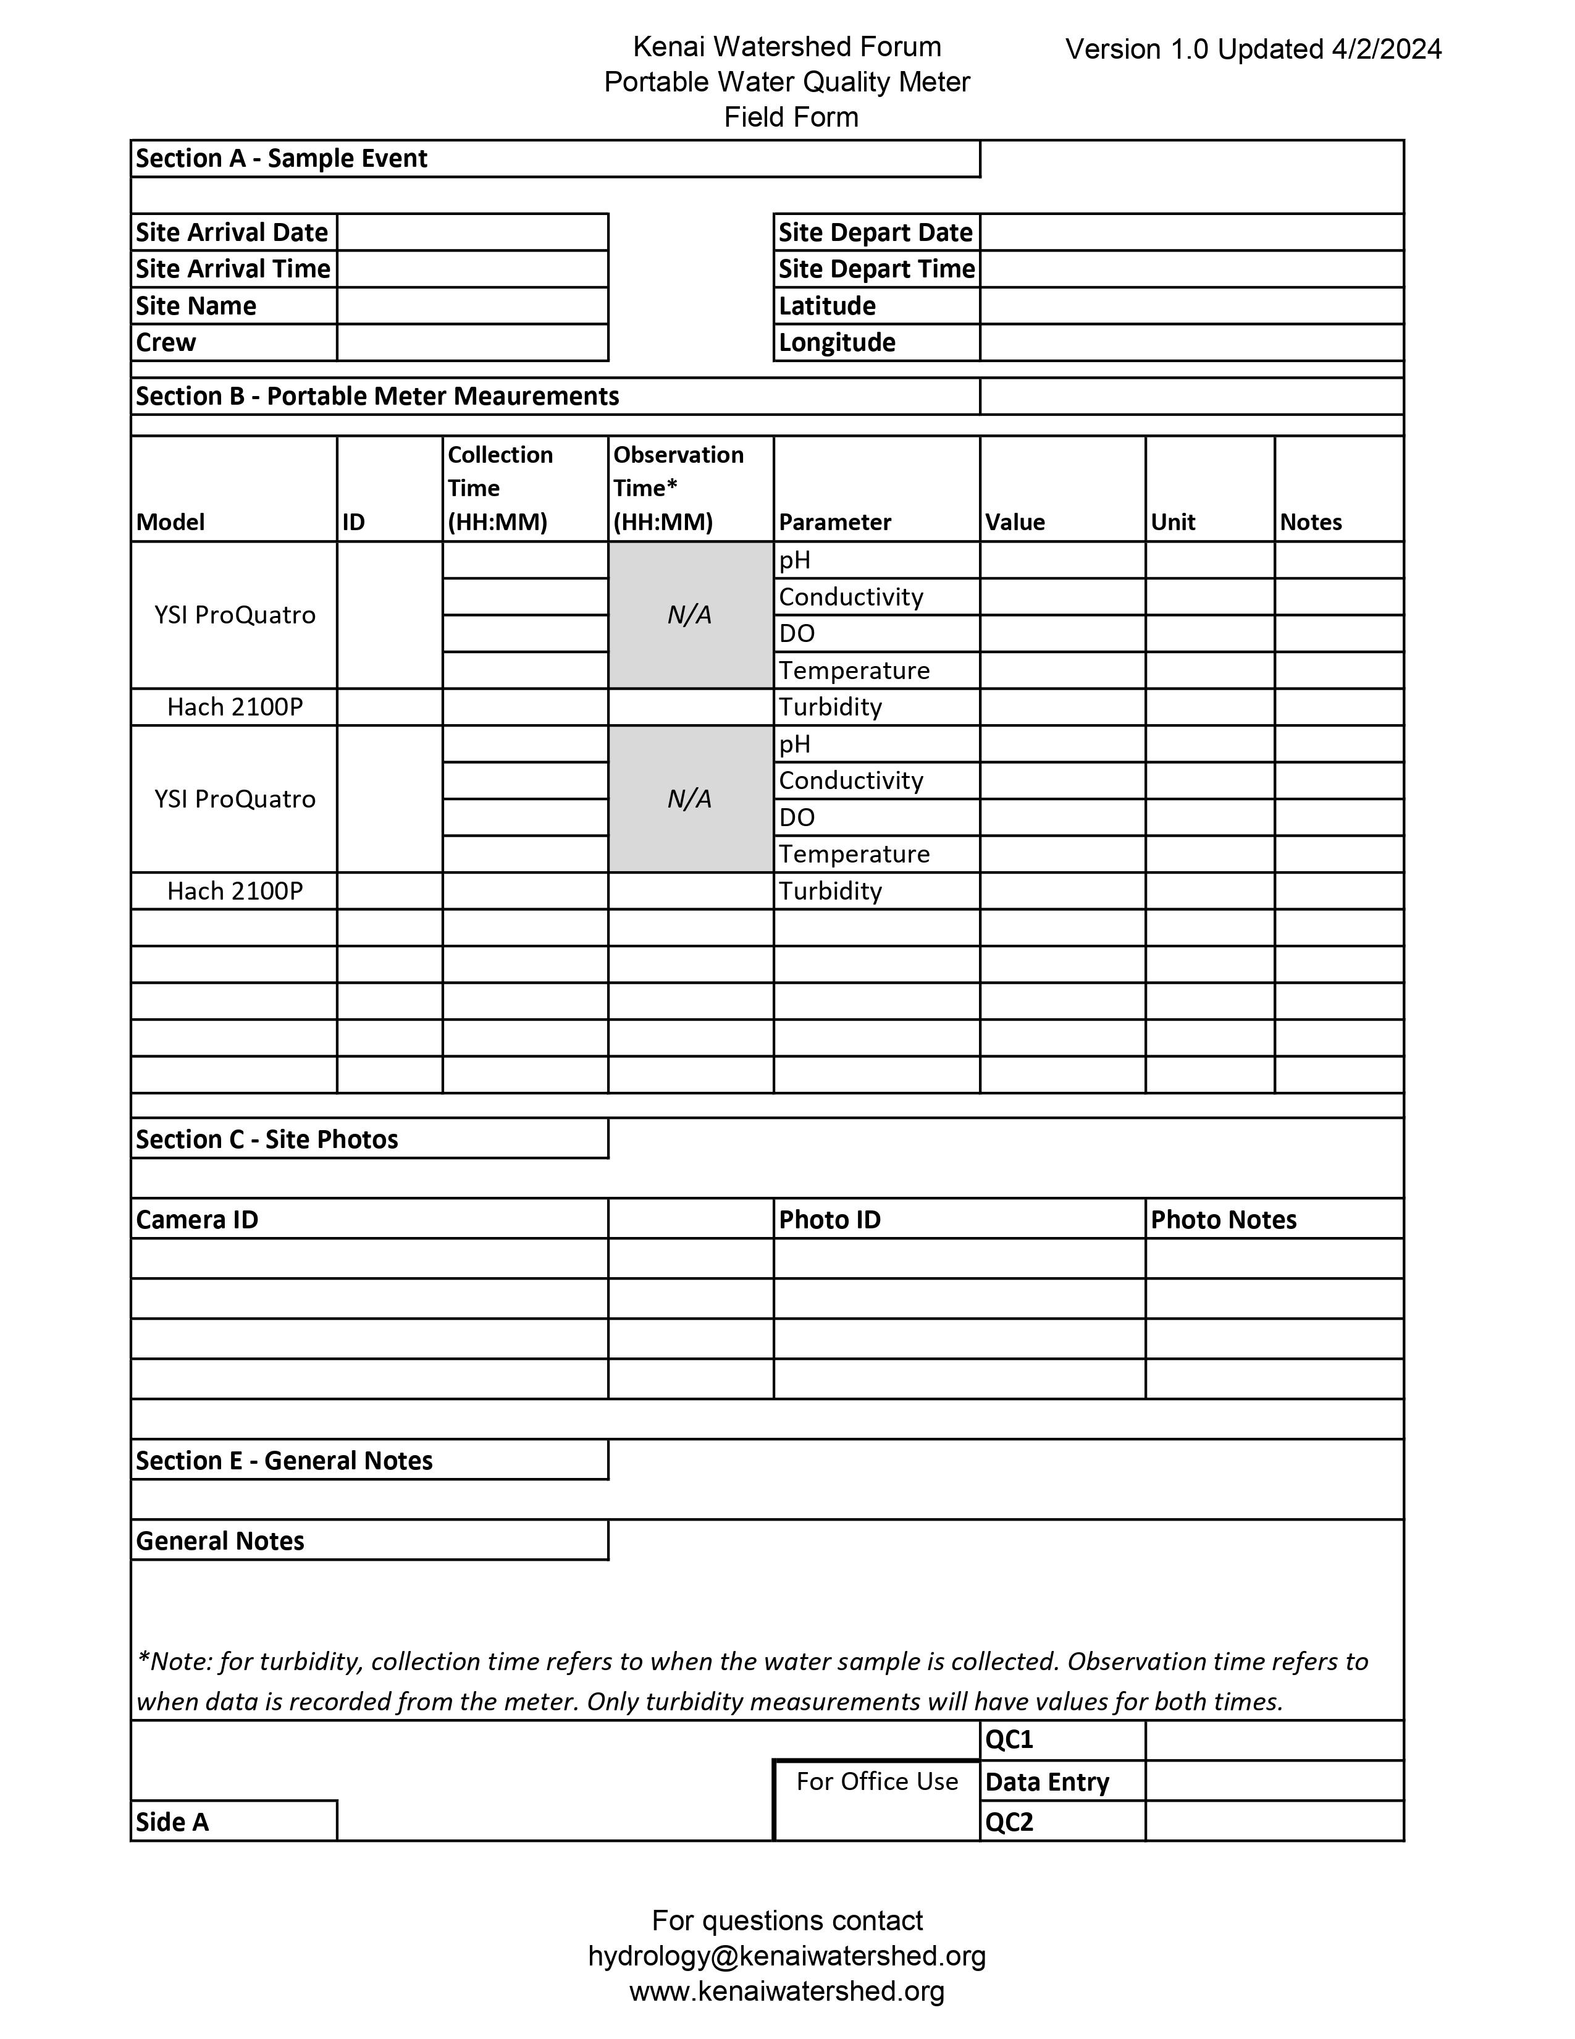

1. <https://www.kenaiwatershed.org/news-media/qapp-revisions-completed-2023/>
2. <https://www.ysi.com/File%20Library/Documents/News%20Briefs/NB13-0116-01-EPA-Approved-Methods.pdf>
3. <https://www.manualslib.com/manual/1279581/Hach-2100p.html>
4. Instrument’s value in user manual for “resolution”